Friday 10th July

Psalm 9:9-10

The LORD is a refuge for the oppressed, a stronghold in times of trouble. Those who know your name trust in you, for you, LORD, have never forsaken those who seek you.

Sometimes we see people go to extraordinary lengths to make a name for themselves! The Name of the Lord in the Bible is a Name above every other, that is powerful and full of authority. Names have always been significant, but in Biblical times they held an even greater weight than perhaps they do today. A name held within it something of the character of the person who owned it. He name of the Lord was considered so awesome, that the people of Israel wouldn’t speak it. In Philippians we read that Jesus is the Name above every other name, and that at His name one day every knee will bow. In these verses we see that the Name of the Lord is trustworthy. He will always respond to us when we seek Him, because of His Name - that is who He is - He has made a name for Himself in faithfulness and compassion. And so, when we call on His Name, He will not turn away.

Lord, your name is great. We praise you, Jesus, name above all names because yours is he only name by which we may be saved. Thank you that you are a refuge for the oppressed and a stronghold in times of trouble. We run to you today. Amen

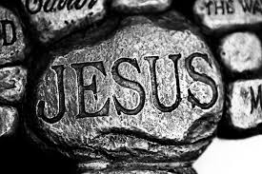

‘Jesus, name above all names’

