Daily Prayer and Encouragement Thursday 7th January - John Bemrose

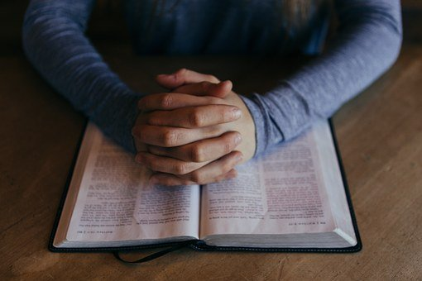
John 15:18-20
“If the world hates you, keep in mind that it hated me first. If you belonged to the world, it would love you as its own. As it is, you do not belong to the world, but I have chosen you out of the world. That is why the world hates you. Remember the words I spoke to you: No servant is greater than his master. If they persecuted me, they will persecute you also. If they obeyed my teaching, they will obey yours also.”

Jesus spoke these words to His disciples knowing that His time on this earth would soon be coming to an end. Chapters 15, 16, and 17 give us a detailed picture of His encouragement and explanation of some of the difficult things to come, to alert them and prepare them. Now the last time I wrote the ”Daily Prayer & Encouragement”, I highlighted the difference between “Encouragement” and its opposite “Discouragement” – but reading these words of Jesus doesn’t on the surface fill us with positive encouragement! Possibly the opposite might be our reaction and with some fear and trepidation thrown in! Jesus, however, always spoke the Truth – He never painted a cosy, rosy picture of what life would be as a follower of Himself. He didn’t hide the reality of the consequences of their faith in Him. Paul, the apostle, also wrote in his epistle to Timothy “In fact, everyone who wants to live a godly life in Christ Jesus will be persecuted.” 2 Tim. 3:12

It would appear, therefore, that true Christian faith is very much counter cultural and the life we would live in Jesus goes very much against the grain of societal thinking, bringing us into conflict in some circumstances. I am sure that we are all aware of what has been happening in certain countries overseas where the faith of our brothers and sisters in Christ has been brutally tested. China in particular comes to mind, though I am sure there are many others. Perhaps we think that this situation will never arise in our country, but there are growing signs that our Christian freedoms are being challenged and restricted.

This may well sound very negative and discouraging, BUT we can rejoice in a glorious positive – Jesus came to show us the way! He shared our humanity and embraced His sufferings “… who for the joy set before Him endured the cross, scorning its shame, and sat down at the right hand of the throne of God” Heb. 12:2. Through His life, death and resurrection He has overcome the world enabling us by His grace to become part of His family. Let us continue to grow in that knowledge of our identity so that we have more confidence to be able to endure and withstand any opposition which challenges our faith.

Father God we thank you for sending your Son, Jesus, to this world of yours to rescue us from the kingdom of darkness into your glorious kingdom of light. We thank you that our hope and future is found only in you. Please fill us afresh with your Spirit that we may grow in grace and in the knowledge of our Lord and Saviour.

